Department of Religious Studies
Steven J. Green School of International and Public Affairs

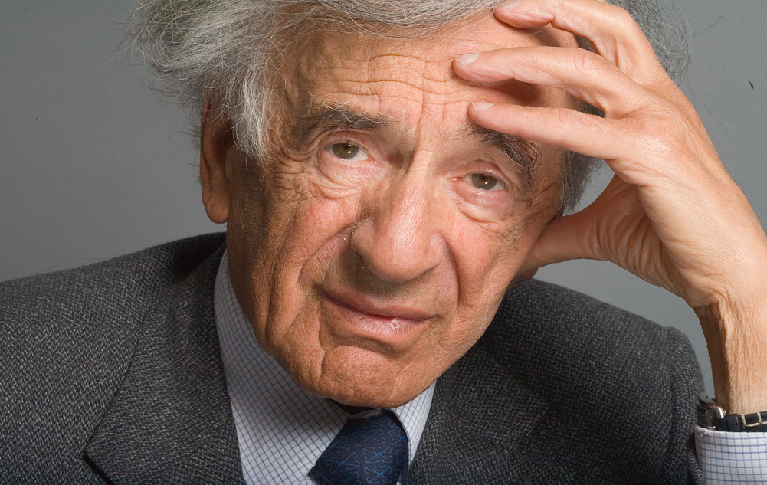

From Night to Dawn and Beyond:
New Course for Spring 2016
No author is more widely associated with the Holocaust than Elie Wiesel. Wiesel is also well known as the voice of the survivor generation. He is one of the 20th and 21st century’s key moral witnesses. His writing is moving, clear, and compelling.
But Wiesel’s output actually extends far beyond the Holocaust to encompass the range of the modern Jewish experience, and his voice rings out periodically as a clarion call against injustice and inhumanity worldwide.
This course will use a selection of Wiesel’s published works—including novels, memoirs, essays, plays, liturgies, and speeches—as a way into analyzing and discussing the modern Jewish experience. During these discussions we will have the opportunity to reflect on the themes of witnessing, ethics, testimony, theology, outrage, and silence, among others. There are no prerequisites for this class.
REL 3603: Elie Wiesel
Tuesdays & Thursdays, 2-3:15pm in GL 137
Taught by Dr. Oren Stier

